Capitalism – the App

Alan Freeman 27 February 2018

Enquiries: [tech@iwgvt.org](mailto:tech@iwgvt.org)

# What is the Capitalism App?

This document explains how to use the ‘Capitalism App’, an educational tool to study capitalist market economies. It is a simulation – it imitates the various things that take place in such an economy, keeping track of what is made, sold, and used, who owns it, where it comes from, where it goes, and what happens as a result.

The user guide is updated regularly but may sometimes be out of sync with the App. See [readme.md](https://github.com/axfreeman/capitalism-9.0/blob/master/readme.md) for the latest status. If the App displays something not in this guide, it’s ahead of the guide. If the guide describes something you don’t yet see (hopefully rarely), it’s a feature still under development. Usually this should be clear from the text.

The App is a testbed for theories about these activities, letting us check both how consistent they are, and whether they are capable of explaining reality. In mathematical terms, it offers [constructive proofs](https://en.wikipedia.org/wiki/Constructive_proof) for economic theories. An earlier version (see ‘[readme.md’](https://github.com/axfreeman/capitalism-9.0/blob/master/readme.md)) showed that some quite simple assumptions can account for the recessions and crises which beset capitalist economies. Since most modern economic theory can’t do that, the App is a serious research tool. In modern language it is a [serious game](https://en.wikipedia.org/wiki/Serious_game).

The App is easy to understand and simple to use, though it contains subtleties that should not be dismissed as trivial. It is the basis of a new departure in economics which allows ordinary citizens to understand, and govern, a system that at present governs them.

Display Controls

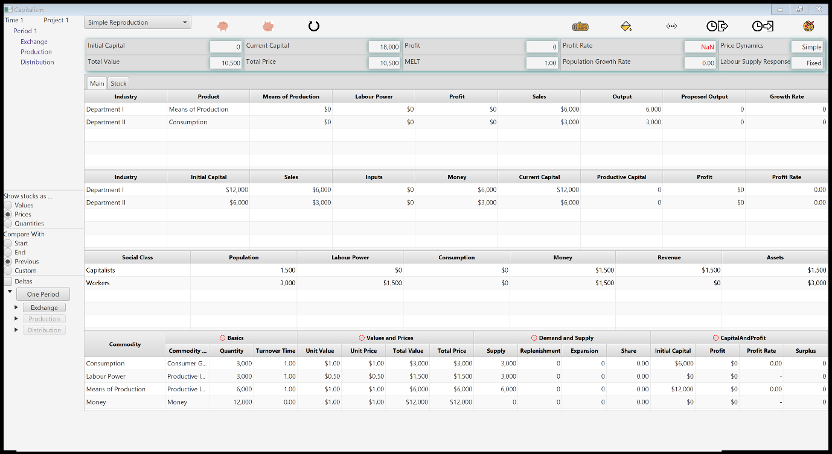

Action Buttons

Review Panel

Display Tables

Figure 1: the opening screen

## How do you run the Capitalism App?

The App is designed to run anywhere, in particular Android and Apple. [Readme.md](https://github.com/axfreeman/capitalism-8.0/blob/master/readme.md) explains how to run it on non-Windows machines. This guide assumes you have a Windows machine. First download [Capitalism.exe’](Capitalism.exe') from [github](https://github.com/axfreeman/capitalism-9.0). You can run it from anywhere on your computer. The App creates a folder called ‘Capsim’ in your Documents folder, with two subfolders called ‘logfiles’ and ‘data’. You don’t have to know what’s in them, but it can be helpful.

Currently, the App just overwrites the data and logfiles when it starts up, except for one file called ‘archive.log’ which you should send me if something goes wrong. If you want to keep them for later, make a copy before you re-start the App.

When it starts, you should see a window like Figure 1, above. It may be sized differently, depending on your machine’s screen resolution. If it looks really weird, let me know - it hasn’t yet been tested on a variety of machines.

## A walkthrough of simple reproduction

The simplest project, which will introduce you to the app’s main features, exhibits ‘Simple Reproduction’ using a [numerical example first studied by Karl Marx](https://www.marxists.org/archive/marx/works/1885-c2/ch02.htm#1).

Stage 1 of the circuit - purchasing commodities

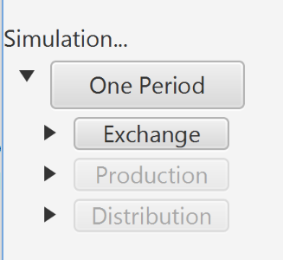

Stage 3- selling commodities and distributing the profit

Stage 2- producing commodities, reproducing classes

Expansion icon

Figure 2: the action buttons

At the bottom left of the window is a set of *action buttons* (see Figure 2). Click onceon the button labelled ‘One Period’. This takes the economy through one complete cycle or *circuit,* in which it buys stocks of goods, consumes all or part of them, and replaces all or part of what it consumes. This is known as ‘reproduction’. Conceptually it’s the same as the ‘circular flow of income’ in the national accounts but provides more detail and is easier to understand. Critically, it tracks *stocks* or inventories of goods, and their relation to *flows* (see §6) of quantity, price, and value. These ideas are explained in this guide, and in a glossary at the end.

Underneath the ‘one period’ button you will see three buttons labelled Exchange, Production and Distribution. The last two are greyed out or ‘disabled’ and you can only press the Exchange button. Do that.

Now the tables are clearly different. The screen should look like Figure 3. The numbers in red are the quantities that have changed, from before the Trade button was pressed. This illustrates a key feature of the app: it exhibits changes between one state and another.

Just above the action buttons, you will see a small checkbox marked ‘deltas’. Try checking it. The red numbers will now display the size of the change, instead of their new value. You should see a small ‘±’ sign in front of them, to draw attention to this.

In this simple case the economy reproduces ‘perfectly’ – it is the same, after pressing the ‘one period’ button, as it was before. Some variables have been calculated that we didn’t know at the outset, such as the rates of profit, or supply and demand. But everyone owns exactly the same at the end of each period as they did at the beginning. Economists say such an economy is in ‘equilibrium’ and base their theories on it. As more commonly stated, they assume the market is perfect.

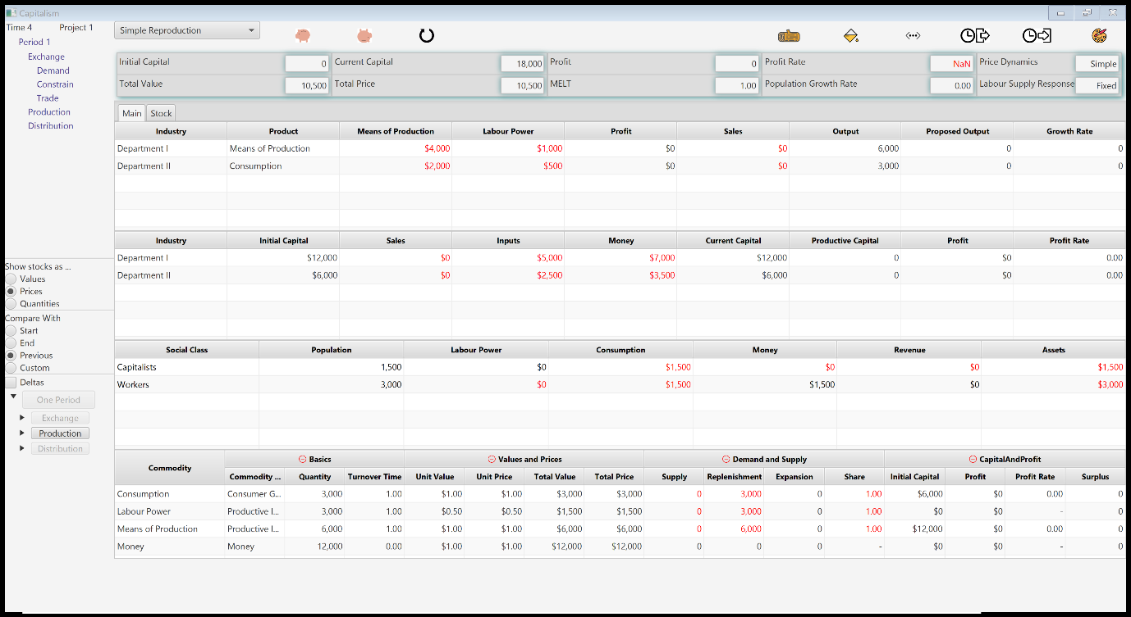

Figure 3 The Simulation after pressing the Exchange button

Hover the mouse icon over any table or enabled button. A short explanation of its content and purpose will pop up.

This may seem like a crude simplification, and it is – but almost all modern economic theory is wedded to the assumption that real economies work like this. This is why they cannot explain what happens.

The Capitalism App, in contrast and in common with Marx and Keynes, uses a completely different approach, called [Temporalism](http://copejournal.com/), which is much closer to the normal approach of the natural sciences; It tracks how the economy moves from one state to another – without ever assuming that, in doing so, the economy will reproduce itself. That is why it can understand crisis, which is what happens when the economy fails to reproduce. However, first things first. The next step is to learn how the App works by studying this simple case.

Press the ‘graphics’ button in the display control buttons panel. Text descriptions will, wherever relevant, be replaced by pictures, letting you focus on the numbers

## The action buttons

Note that once you have pressed the Exchange button, it is disabled, and the Production button is enabled. Conceptually – but see later – the economy has finished trading and is ready to produce. Press the Production button. You will now see the screen exhibited in Figure 4. Finally, press the Distribution button, to return to the start of the next circuit. Note that in this simple case, nothing has changed – that’s why it’s called ‘reproduction’.

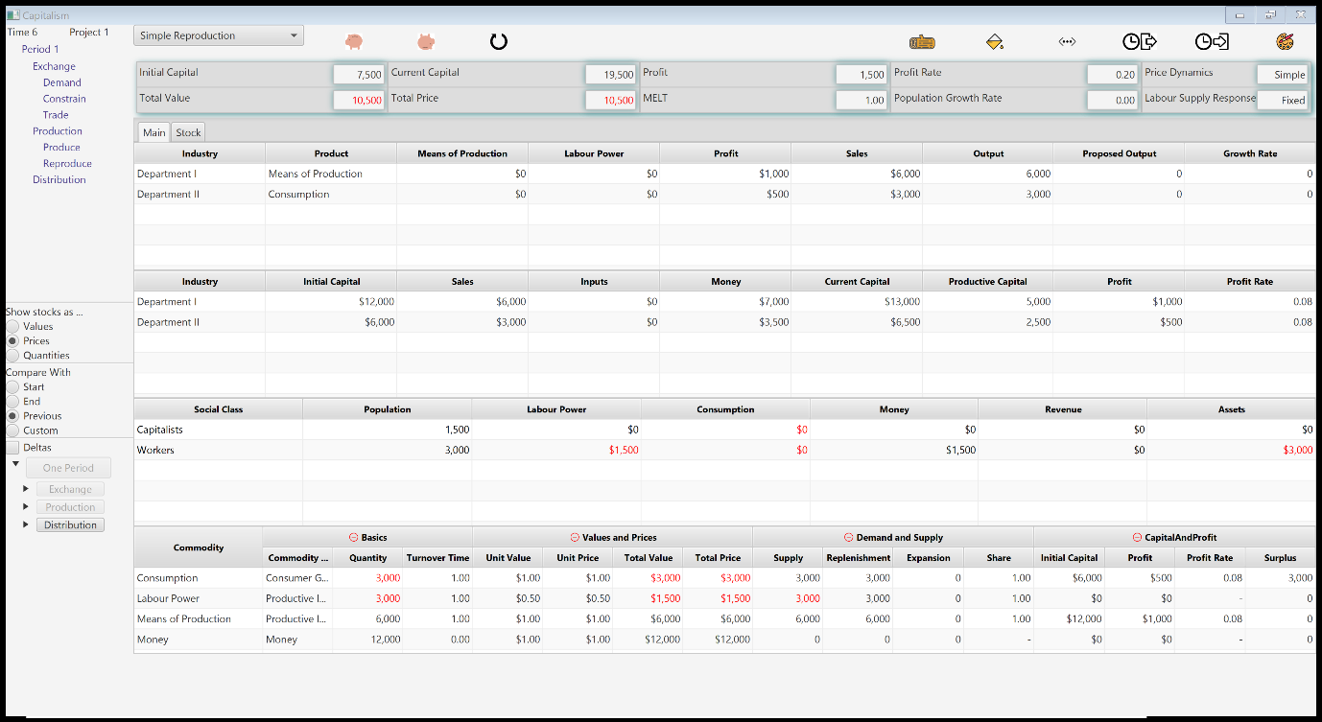

Figure 4 After pressing the production button

## Digging deeper: the action detail buttons

To the left of each action button is a small triangle, the ’expansion icon’ (see Figure 2). Click on the triangle next to the Exchange button. The display ‘expands’ much like the directory tree in Windows Explorer. It should now look like Figure 5. Click again and it will contract, looking like Figure 2 again. Click it again to return to the fuller display in Figure 5.

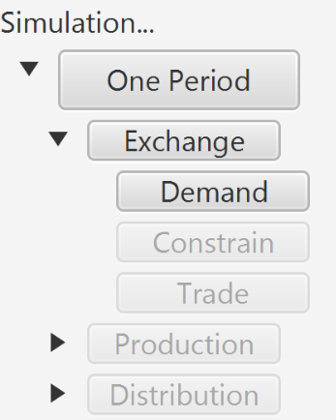

Figure 5 expanded trade (M-C) button

The buttons labelled ‘Supply’, ’Demand’ and so on provide a logical breakdown of the trading phase of the circuit into smaller components that show how the overall calculation is done. Press each in turn and observe how the screen changes. The explanation is given later – at this stage, you are just finding out how to use the simulation (and you can skip ahead if this part seems obvious). When you have carried out the last step called ‘Trade’, the screen should look like Figure 3, as if you had simply pressed the ‘Exchange’ button. This is because the Exchange button simply carries out the four actions you just stepped through one by one.

You can satisfy yourself that the Produce and Distribute buttons each have two sub-actions, and that at the end of the very last sub-action (‘Accumulate’), one whole circuit is complete.

## The ghost of capital past: the review panel

The Capitalism app contains tools to adjust the display. Most are in the top right group of buttons. Try the ‘graphics’ and the ‘decimal’ button (Screen Clipping).

At the top left of the screen is the review panel, shown in Figure 6. When the simulation starts, this looks like Figure 6A; after Exchange it looks like Figure 6B. If you double-click on the Exchange label in the panel, the detail is suppressed, and it looks like Figure 6C.

The panel lets you review calculations that have already happened. It is only a window on the past and does not ‘undo’ the simulation. To see it in action, expand the Exchange branch of the review tree (by double-clicking on the Exchange label in the review panel) and click *once* on the ‘supply’ label.

|  |  |  |
| --- | --- | --- |
| A: at the start  Screen Clipping | B: after Exchange, with the tree expanded  Screen Clipping | C: as B, but with the tree contracted  Screen Clipping |

Figure 6 the review panel, expanded and unexpanded

The numbers displayed will revert to the state of the simulation directly after the ‘supply’ action was executed. Click on the ‘demand’ label and note what is now displayed. Finally click once on the Exchange label. The display now shows the state of the simulation after all four Exchange actions (Supply, Demand, Allocate, Trade) have been executed.

## Studying the action as it happens: the log tree window

|  |  |
| --- | --- |
| Screen Clipping | Screen Clipping |

Figure 7 the log window, contracted and partly expanded

In the row of buttons at the top right, you will see a button marked ‘log’. Press it. A window like Figure 7 pops up. Click on the expansion icon (the little triangle) next to ‘Demand’ in that window. This branch of the log tree expands to show two lines of text coloured red, each with its own expansion icon. Click on the first. The log tree expands again and should now look like the second window in Figure 7 (you may have to stretch the window to see all the text). The log window shows you, blow by blow, the calculations that the simulation has made – what was produced, who bought it, how much they paid for it, and so on.

Unlike successive periods, sub-actions like ‘demand’ do not refer to activities that take place one after another. Rather, they show logical steps in the calculation.

### Three views of history: actions, flows and stocks

The action buttons, the review panel and the log tree all show different aspects of the same hierarchy. They let you step back to look at the big picture, or step into one detail without being overwhelmed by numbers. The buttons say what action is taken. The log tree shows the flows that result from these actions and how the flows are calculated. The review panel lets you see the result of the flows. In the next section, we say a bit more about these terms.

# What am I seeing?

So far, we have only covered how to make the simulation ‘work’, though I hope it’s whetted your appetite to understand what the numbers mean. In this section I try to give a plain, non-technical explanation of what they tell you, without getting into too much of the theory. In the final section, I will start looking at the theory behind what we are doing, and introduce you to some more sophisticated simulations.

You can make your own simulations, but this is not yet fully working. If you feel intrepid, you can explore the ‘load’ and ‘save’ buttons. You may also want to take a look at the ‘Projects’ drop-down button immediately above the review panel.

## What lies beneath: the main tables and the stock tables

The main display is *tabbed*. The tabs are the little labels above the tables panel, which look like the plastic tabs on filing cabinets. There are actually two sets of tables, but you can only see one at a time. Click on the ‘Stocks’ tab; the results, shown in Figure 8, show what lies behind the information in the main tables.

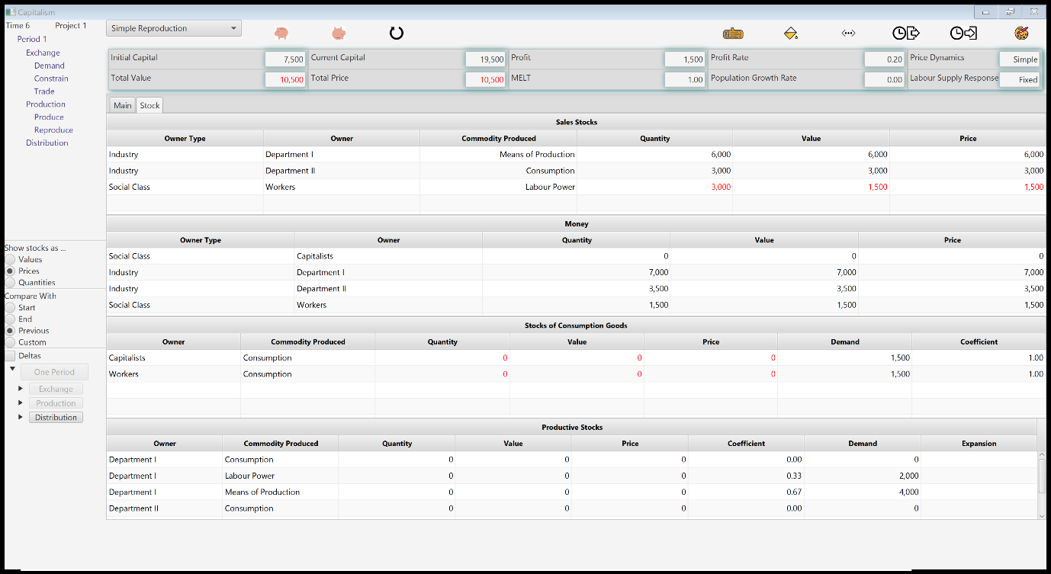

Figure 8 the stock tables

Each entry represents a stock of some commodity which is owned by someone. A commodity is anything that is produced to be sold – it can be a consumption good like food, clothing, or housing, or it can be a means of production, such as machinery, iron, or electricity. It can also be a service, such as labour power – the capacity to work.

Stocks can be measured in three ways: their quantity, their price, and their value. These are explained more fully, later in this guide and in the glossary. For now, check out the ‘show stocks as’ buttons in the review panel, and the two buttons marked ‘#values’ and ‘#prices’ in the display controls.

Returning to our review of the stock tables; the top table shows *sales stocks* or inventory which are available for purchase. Each row shows one type of commodity or *use value*. It also shows who ownsthe stock, and is hence entitled to sell it. This also constitutes the supply of the commodity.

## Ownership, class and industry

Capitalism is a system based on private property. Each stock is ownedby some ‘legal person’ who may either be an individual or a corporate body such as a business or the government. Any group or *class* of legal persons can also ‘own’ a stock – for example, the banks own a lot of money. Two such groups are a key feature of the simulation: *Social classes* are groups of people such as workers, industrialists, bankers or landowners, whose income depends on owning a particular kind of property. *Branches of production,* sometimes known as sectors or industries*,* are groups of businesses or public bodies such as farmers, manufacturers, or hospitals, that produce a particular use value.

## Productive stocks, sales stocks, money stocks and consumption stocks

Different businesses can produce the same use value, and the same businesses can produce several use values (products). This feature is under development.

The stock tables show how much of each use value is owned by each social class, and each branch of production. They also group the stocks into four major types, each shown in a separate table. *Sales stocks* are the inventory produced either by a branch that sells its product, or by a social class that sells a productive service, such as labour*. Consumption* stocks are used by social classes to reproduce themselves. *Productive* Stocks are used by branches to make things. Last but not least, *Money* stocks are used to buy things.

Looking at the stock tables after exchange is complete, you can see for example that the workers and the capitalists both have $1500 worth of consumption goods and no money. The two branches producing Means of Production and Consumption Goods have $7,000 and $3,500 respectively.

A class can own an entity which owns something else, so the capitalists own branches of production as well as stocks. This will become clearer when we study distribution.

As well as the ‘quantity’ of each stock (see later) the display records its price and its value. In this simple example, the price and value are the same, and both are equal to the quantity, but in general, as we shall see, these magnitudes differ.

## The main tables

The main tables present the same data in a more accessible form, but most importantly provides additional information about the results and ‘rules of conduct’ of the simulation. I will summarise them here but provide more detail later, because it is important not to lose sight of the big picture by becoming immersed in the detail.

Topmost (Figure 9) is the *Commodities* table. For each type of commodity, this records its quantity, value and price and also its unit value and price, all ideas that are more complex than might be thought – see the next section. It also displays the supply of this commodity, the demand for it, and the proportion of this supply that will be allocated to demanders.

You can define how an economy responds to disparities between supply and demand, but it will call for some work: join the App Community and help develop the plugins.

Below the commodities table are two views of the branches. The *Industry Accounts* table shows how profit is made up. It shows what the branch has to sell (its sales inventory), and the inputs it uses for production. After that comes its money capital, and finally the total of all the above which is the ‘capital advanced’ – the total needed for the circuit to function. The profit, of which more later, is simply the difference between the capital advanced to the circuit before and after production starts, and the profit rate is the ratio of profit to capital advanced.

The *Industry Production* table shows how each branch of production makes its product. It consumes *inputs –* raw materials, machinery, and labour - to make *output.* The output column is what it would produce, if it could acquire all the inputs it needs. Since producers can’t always lay their hands on everything (because of disparities between supply and demand), the actual output is *constrained.* Output will also be constrained if the producer doesn’t have enough money. In later versions of the App, credit and debt will be introduced; however neither in real life, nor in the App, can anybody create debt without somebody else owning that debt and agreeing to do so, and without the conditions of the loan being agreed and recorded as the relevant flows.

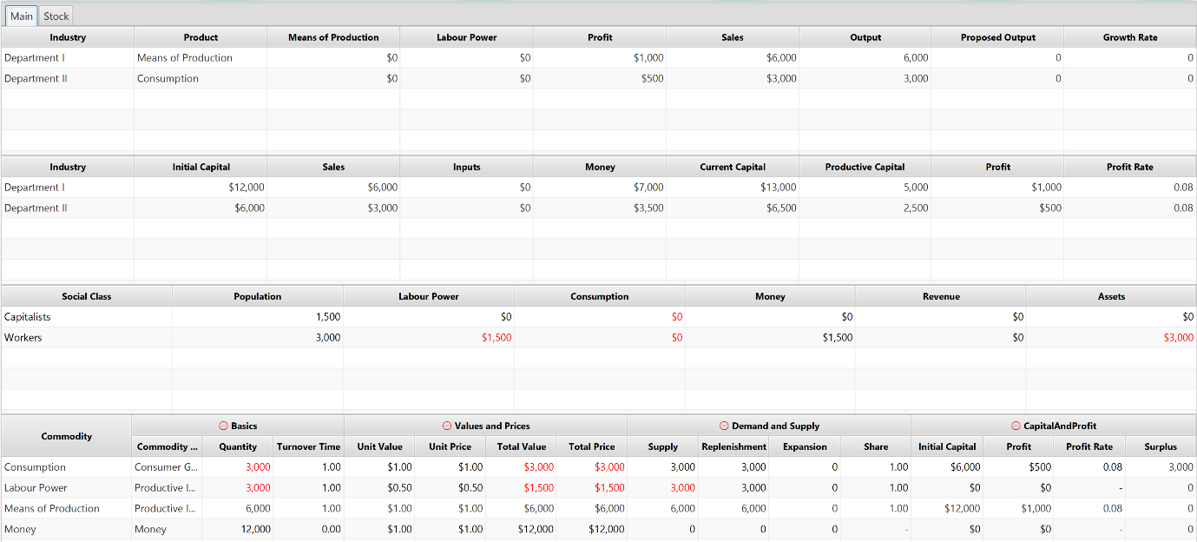

Commodities

Industries: Production

Social Classes

Industries:Accounts

Figure 9 the main tables after exchange

Finally, the *Social Classes* table shows what each class owns, consumes, and has to sell.

# How does it work?

## Stocks, flows and movement

What happens when you step through the simulation? The app provides a *stock-flow* simulation of the economy. It simulates three types of flow; flows which transform commodities into other commodities (production), changes in ownership (trade, sometimes called exchange), and transfers of value (distribution).

The app adheres to [*stock-flow consistency*](https://en.wikipedia.org/wiki/Stock-Flow_consistent_model)*.*[1]When a flow takes place, the total amount lost or gained is equal to the balance of the flows into and out of the system as a whole. This is a very easy principle to understand, because it is in very common use elsewhere: for example, if you are filling a bathtub from a tap while the plug is pulled out, then between any two points in time, the change in the quantity of water in the tub will be equal to the amount that came in via the tap, less the amount that went down the plughole. In the same way the growth or shrinkage in population of any species, over any period of time, is equal to the balance of births and deaths. And so on.

The principle applies first and foremost to the total quantity of any stock in existence, which is the sum of all stocks of the same type. If we want to know how much corn is in the economy at any time, we ask how much was there at any previous time, add what was produced between then and now, and substract what was consumed or wasted.

We can either think of waste as a special flow in its own right, or as a kind of consumption. It makes no difference to the principle. In the App, waste is not accounted for separately, but it would be perfectly simple to do so.

### Keeping track of trade: stock-flow consistency for prices

But it also, less obviously but no less logically, applies to the price of the corn. The price of all the corn in the economy is the result however of two types of change – a change in its quantity, and a change in its price. If the price of corn goes up from $20 per ton to $21 per ton, and a farmer owns 20 tons of corn, then his stock of corn rises from $400 to $420, which is to say there has been an inflow of $20 to his stock of corn, measured by its money price.

This is no great mystery; it is exactly how accountants keep track of businesses. The ‘stock’ figure is the balance sheet, showing all the assets and liabilities of the business, whilst the inflows, measured in money, are the profit-and-loss account. The basic accounting principle is that over any period of time, the net wealth or capital of the company changes by an amount exactly equal to the difference between sales and purchases, *plus* any changes due to the revaluation of stock.

Every time a payment is made, the App tracks it. The money flow appears in the log, the payee is debited, and the recipient is credited. Every time a commodity is purchased, a corresponding double entry is made. The purchaser’s stock increases and the seller’s stock decreases and the log tree records the transaction.

Stock-flow consistency thus imposes an invariant condition called exchange-invariance; the total price of stocks is not altered by changes of ownership, that is, exchange.There is a caveat however, discussed in more detail when we consider value. If prices themselves change, total price can and does change. To maintain the exchange-invariance identity clearly, price changes are accounted for *separately* from trading.

A further complication, which we don’t dwell on in this introductory guide, is that not every payment buys something. When a capitalist invests in a branch of production, she or he transfers money to it without receiving anything. Nevertheless, the payment has a counterpart: the money is a loan, and the ‘capital’ of the business – its net worth – is an asset, part of the capitalist’s wealth. Stock-flow consistency is maintained, because it is recorded as a liability for the business, and an asset for the owner.

Can a worker own a business? There is no obstacle to it in the App. If you want to try it, create a branch of the App on Github. The base version always makes the simplest possible assumption – in this case, that everyone has only one source of income, so they either belong in the working class or a property-owning class.

### Price flows and the side-effects of price changes

Without question the most difficult aspect of stock-flow consistency – and perhaps the only really difficult aspect of it – is that when the price of a good changes, the size of all stocks of that good change with it, even though the stock has not changed hands.

Suppose you buy a brand-new iPhone for $600, and the next day find that because of a fire sale, the price of has been slashed to $300. Without anything changing hands, you lost out. The value of your stock has fallen by $300; you are $300 poorer.

Standard accounting practices treat such changes as flows. If you were a business, the $300 would appear on your profit-and-loss account as a write-down – a loss to the business. Your balance sheet would show you as $300 worse off. Conversely, if you had been lucky enough to buy a barrel of oil for $40 and its price went up to $80, this would show as an inflow of $40 on the profit and loss, leading to an increase of $40 in your net worth on the balance sheet. *Price changes bring about flows*: when they fall, they decrease the value of stocks and when they rise, they increase the value of stocks.

These changes are treated as flows. When the price of a commodity rises, the App records an inflow to the price magnitude of every stock of that commodity. If it falls, the App records an outflow.

This very fact, however, highlights the limitation of a price measure. What if *all* prices rise by 10%? If the total stocks in the economy, measured in price terms, is $100,000, then $10,000 seems to have appeared from nowhere. But clearly, nothing has been produced! In fact, we are forced to treat the increase in price as an inflow from the exterior, but the origin of this inflow is very mysterious.

This is where the need for a concept of value makes its appearance.

### Keeping track of production: stock-flow consistency for values

The simulation, uniquely, applies stock-flow consistency to *value.* This is controversial topic in economics, because it is associated with Karl Marx. Actually, every economic theory has a concept of value and if they didn’t, they wouldn’t be able to speak of value-added tax, or value-added in the national accounts. A value concept of some kind arises as soon as we seek to distinguish *production*, in which some ‘thing’ or ‘substance’ is made, from *exchange* in which the produced stuff is passed from owner to owner.

Most economists don’t go any further than supposing, in some quite vague way, that we can measure the ‘quantity’ of the product without any difficulty, so all we need to know is the price and quantity of every stock. They then immediately confront serious logical difficulties such as the ‘index number’ problem which arises because most measures of physical magnitude are not *additive*; you cannot add one tomato to two potatoes and say we have three totatos, or three pomatoes. This leads to quite serious mistakes when a ‘deflator’ intended for one basket of goods is used to estimate the quantity of a different basket, for example when authors estimate the wage share by dividing real GDP by real wages, yielding completely misleading results.

Another approach, most often associated with Piero Sraffa but more generally termed Linear Production Theory, is to suppose that output always contains the same proportions of everything, and worse still, that these proportions are not determined by what the economy is actually doing, but by what it would have to do, in order to reproduce perfectly (which is why the Linear Production Approach is wedded to the equilibrium approach.

Among many problems, this is more or less useless for studying real economies which not only do not reproduce perfectly, but which produce in proportions far removed from the idealised ‘baskets’ of Linear Production Theory.

TSSI scholars term such ideas *physicalism:* they confuse the physical or material properties of the commodity with the activities that produce it. To be consistent, a value concept needs to separate production from exchange in such a way that exchange can only ‘move around’ the substance of production and cannot create it. This should be obvious: logically, if an act of exchange did create some new stuff, it would be an act of production, not an act of exchange.

However, most value concepts turn out to be inconsistent at least in this respect; not least, the national accounts have since 1995 treated banking – an activity which simply manages money – as if it produced something.

I analyse the various concepts of value in a document called *Mathematical Foundations of the Value Theory of Finance.* Because this is being considered for publication, I can’t make it publicly available. Write to me and I will send it.

A theory of value lets us talk about production in a systematic way, by keeping track of what is produced. A value concept that achieves this must have the following three characteristics: its total should not be modified in exchange; it should be additive, which means the value of any two commodities is equal to the sum of their separate values; and it should be ‘functionally dependent’ on production, which means that if two commodities have different values, the difference depends on the variables of production alone.

I call these three value principles *production-consistency.* The basic version of the App uses the value concept of Marx, as interpreted by scholars who work with the *Temporal Single System Interpretation* (TSSI), precisely because it is production-consistent. You can find out about more by reading Marx, or you can visit the IWGVT [website](http://copejournal.com/), or you can simply follow what the App does.

Developers can introduce different value concepts. However, will have to specify how much value is created in production, and how to add up or ’aggregate’ these values so we calculate things like the value owned by a social class. The difficulties may not prove insurmountable, but do impose a discipline which demands clear thinking.

The key practical issue is *when the additional value appears*: the App calculates this, as might be expected, in the production phase. In the base version, the value of new sales inventory is the sum of the values of all consumed inputs, plus an additional amount proportional to the time the labourers work.

Here’s where the complicated bit comes. Value can be calculated, or *expressed,* in units of time, or in units of money. The ratio between the two is called the MELT or *Monetary Expression of Labour Time**.* So, for example, since a typical or average US worker adds about $120,000 to the national product each year, the MELT is $120,000 per year or about $60 per hour. The MELT is the same for all commodities at any given time. It is displayed in the ‘Globals’ panel at the top of the App. If an alternative value concept is used in which labour time does not figure, the App will calculate a ‘Monetary Expression of Value’ instead. For a physicalist concept, this will just be the price level.

In general, price and value are not the same, because goods can sell for any arbitrary price, though on average over time they tend to be correlated. The difference provides valuable information: if for example a coat has a value of $50 and sells for $60, then we can say that it is selling at 20% above its value. This highlights an important point discussed next: price is a *modified* value*.* Instead of telling us how much value went into producing the input, tells us how much value we can lay our hands on by buying it.

You can switch between two *expressions* of value using buttons in the display controls. Press  to display their *intrinsic* expression (usually time); the button label changes to A close up of a logo

Description generated with very high confidence. Press it again to display their *extrinsic* (money) expression.

The symbols can be customized. Switch to project 5 to see an example.

We can summarise this quite simply: the value measures what the producer puts into the commodity and the price measures how much of this the purchaser acquires. This is why we use the graphic symbol A close up of a logo

Description generated with very high confidencefor value and A close up of a logo

Description generated with high confidence for price: the first is value as it leaves production and the second is value as it enters consumption.

A common mistake is to suppose that ‘prices’ are money whilst ‘value’ is time. [Ramos](http://copejournal.com/wp-content/uploads/2017/02/Ramos-The-Monetary-Expression-of-Labour-Marxs-Twofold-Measure-of-Value.pdf) shows that every value, and every price, can be *expressed* either in time or money. Their ratio is the MELT. Thus, the button will switch between the two expressions of prices, because price is a form of value and can therefore be expressed in time or money. The symbols attached to price magnitudes will change when the button is pressed.

In keeping with the TSSI, the value transferred to the product by an input is therefore given by the price of the input at the time of consumption, and equally, if a consumption good is consumed, the value thus destroyed is equal to the price, not the value, of the good.

Press A close up of a sign

Description generated with very high confidence.The various columns are lightly coloured, to show which are simple quantities (silver), which are values (red) and which are prices (values). Press it again. The colours vanish.

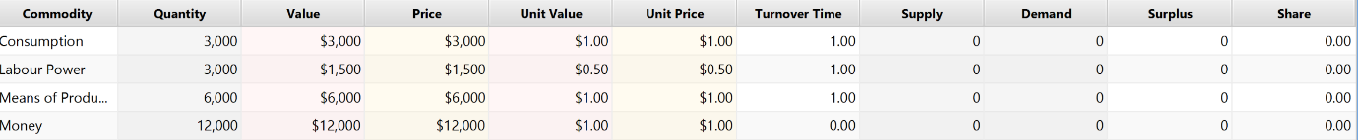

Figure 10 The use value table with coloured hints, and the currency(extrinsic) expression displayed

### Accounting for change: side-effects of value variations

A value measure isolates the effects of production from these effects of distribution. The total value of all the stocks in the economy can *only* change if something in production has changed. Neither price changes, or exchange – changes of ownership – can affect this total.

There are still side-effects of value changes, but a new principle imposes itself: the total value in existence cannot be increased by modifying prices. This is a key difference between the value and the price measure of a stock. When unit prices change, the total prices of all stocks can, and does rise, making it appear as noted that price has flowed in from, our out to, somewhere not in the system. The total *value* of stocks, in contrast, does not change.

However, though the total is constant, its distribution is not. Value can ‘flow’ from one owner to another, and does, especially when technical change is going on.

To fix ideas here, first look at the effects of a change in the value of a single commodity; suppose there are 60,000 tons of steel in the economy, with a value of $10 per ton: $60,000 altogether, or 500 person-years using the MELT calculated above. Now suppose an efficient new steel mill produces 60,000 more tons whose total value is only $30,000 because the mill uses fewer labourers. There are now 120,000 tons of steel with a total value of $90,000. The new average value of steel is $7.50 per ton or 1/16 hours per ton. This latter is the ‘socially necessary’ labour time that has gone into the steel.

We account for this as a flow as follows: the owners of the old steel have seen their stocks fall from $60,000 to $45,000. They have lost $15,000, or 250 labour-hours, in value. Where has it gone? To the more efficient producers whose sales inventory steel is worth $45,000 even though their individual production contributed $30,000. We may argue about the terminology, but the facts are straightforward; one group of steel-owners has lost $15,000 and the other has $15,000 more.

Equilibrium theories suppose that ‘socially necessary labour time’ is the ‘current cost’ or the unit value of the most efficient factory, and so falls to $5 or 1/24 hour per ton as soon as the new factory winks into existence. the historic cost of the old steel is spirited away, which is why such theories cannot account for the long-run tendency of the profit-rate to fall.

We treat this exactly as a bookkeeper treats price variations: $15,000 in value has flowed from one group to the other.

### What happens to the value of a stock when its price changes?

The value of an individual stock can, and is, modified by price changes. Suppose all the oil in the economy is worth $1,000,000, and the price of oil halves. Clearly, anyone who owns oil is worse off. The value they own has halved. These losses of value have to be treated as flows. Where has the lost $500,000 gone? To take the simplest case, let’s suppose the stocks of steel in the economy had a value of $500,000 and that, at the same time that the price of oil halved, the price of steel doubled, and no other prices change.

It’s quite easy to see what has happened: the $500,000 lost to the oil-owners has been gained by the steel-owners. Or, in terms of stocks and flows, there has been a flow of $500,000 from oil-owners to steel-owners.

In general, any set of changes in relative prices will bring about flows in value, from one stock to another, which equal out to zero. This is what we mean by saying exchange is a zero-sum operation for value. It can neither add to it, nor reduce it.

But what if *all* prices rise or fall? Suppose in the above example that with no relative price changes, everything goes up by 10%. The Oil has gone up to $1,100,000, the steel to $550,000 and the linen to $275,000. The total has gone up by $175,000. If this is to represent an acquisition of value, where did it come from? It is here that the double expression of value helps us. When prices rise, this establishes a new MELT. Measured in hours, value has not been created. Measured in money, value only appears to have been created; all that has really happened is that the same number of hours are now expressed in 10% more money.

### Does money have a value, and does it matter?

A glance at money stocks table shows that they are recorded as having a price, a quantity – and a value. This requires some explanation.

The quantity is the simplest measure; it is the face value of the money, which is printed on it. If a bank owns $10,000,000 in dollar bills, then the quantity of money in its hands is 10,000.

Price is more problematic: technically, money does not have a price, because it is the unit in which prices are reckoned. It makes no sense to buy a dollar with a dollar. Nevertheless, we need this magnitude to calculate magnitudes like the capital of an enterprise. If, for example, a steel business has $20,000 worth of iron, $10,000 worth of coal, a factory worth $100,000 has contracted $20,000 worth of labour and also keeps $100,000 in the bank to pay bills with, its capital is more than the material costs of $20,000 + $10,000 + $100,000 + $20,000 = $150,000. If the capitalists only loaned the business this sum, it would be insolvent, because it couldn’t pay its bills. The actual capital advanced is $150,000 *plus* the $100,000 in working money capital, that is $250,000. Moreover, if the business makes $30,000 in profits in the year, the rate of return or profit on this capital is not 20% but 12%, being $30,000/$250,000.

Every capitalist and every accountant knows this, but it is, surprisingly, left out of account in most calculations of the profit rate. It is rather a material fact: if we leave out of account the financial, or money assets in the US economy, it looks as though the rate of profit recovered after 1980. If we include these assets, it has not stopped falling since 1968. Yet almost all writers on the profit rate unaccountably leave out this essential component of advanced capital.

This is also highly relevant to crisis, precisely because in a crisis, idle money starts to accumulate as hoards. Whilst this has no effect on profit rates if it accumulates as currency or other non-marketable monetary instruments, once there is a market in money instruments – financialization as it is sometimes called – then these acquire a claim to the total profit that the economy produces, so that ever more capital accumulates in the shape of money, and correspondingly less in the shape of productive assets.

OK, this accounts for the ‘price’ of money, which is in reality a measure of the capital tied up in money. What about its value? How can something that costs little or nothing to produce nevertheless have a value? Must it actually be a commodity, such as gold? The answer is really very simple and has already been explained in essence: just as the price of a normal commodity is its ‘consumer-facing value’ – the amount of value that this commodity brings to the purchaser, in contrast with the value with which it leaves production – the value represented by a stock of money is the value it *represents in exchange* – that is, the value of the goods for which it can be exchanged. Its money expression is thus the face-value of the money stock, or what we have just called its price; its labour-time expression is this face-value, divided by the MELT.

# Glossary (to be completed)

This section contains some brief explanation of the terms used in this guide. They are not intended as precise definitions (for fuller discussions on their meaning, read the accompanying literature and the worked examples). Here, you will find a kind of quick reference to help you understand what the App does.

### Action Buttons

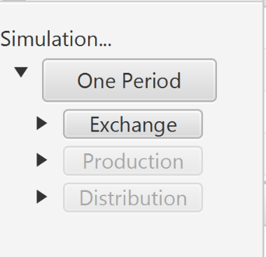

The group of buttons on the bottom left of the window. Pressing one of these takes the simulation one step forward. Pressing the ‘expansion triangle’ next to an action button expands it to show its component actions. This allows you to choose between taking one small step at a time or combining them in logical packages. If you want, you can press the ‘One period’ button and execute all of them, one after another

### App

### Capital

The sum of the prices of the goods owned by an industry including its productive inputs, any labour power which it has engaged, its money, and its sales inventory.

### Capitalism

Of course, there are many definitions of capitalism; in this application, the key point is private ownership of production. Production is carried out in privately-owned industries with wage labour, and the owners are entitled to receive the profit from these industries.

### Commodity

In the app, the term is loosely used to describe any useful thing that is bought and sold. This includes some things that may not be produced industrially, such as money.

### Extrinsic value expression

### Hoard

A hoard – usually a money hoard – is a stock that has been accumulated or saved, and is not being used for anything. Strictly speaking, money hoards are being used as a store of value; the point is, however, that they are not being used to buy anything or produce anything.

### Industry

An industry is a collection of enterprises that produce the same commodity.

### Intrinsic value expression

### Monetary Expression of Labour Time (MELT)

The amount of money which represents a given quantity of labour time in exchange. Any value or price can be expressed either in money, or time. The former is sometimes called its extrinsic expression and the latter its intrinsic expression. The MELT is the ratio of the two. It changes over time, but at any given time it is the same for any stock of commodities.

See [Ramos (1995).](http://copejournal.com/wp-content/uploads/2017/02/Ramos-The-Monetary-Expression-of-Labour-Marxs-Twofold-Measure-of-Value.pdf)

### Physicalist

### Price

### Profit

The difference between capital before and after production has taken place, measured in price terms. The App keeps track of the profit of individual industries, of commodities (since more than one industry can produce the same commodity) and of the whole economy.

### Sales inventory

### Simulation

### Temporal Single System Interpretation

See [www.copejournal.com](http://www.copejournal.com)

### Value

### Zero-sum

1. See <https://en.wikipedia.org/wiki/Stock-Flow_consistent_model>